Exploratory Data Analysis Report
Customer Personality Analysis Dataset
Module 04 — Machine Learning Internship | AI Lab 99

1. Dataset Overview
This report presents an Exploratory Data Analysis (EDA) of the cleaned Customer Personality Analysis dataset (2,237 customers, 33 variables), produced after the Data Cleaning and Preprocessing module. The dataset has no missing values or duplicate records, correct data types, and standardized categories. The goal of this analysis is to understand customer demographics, spending behaviour, channel preferences, engagement, campaign performance, and to surface actionable business insights.
Property | Value
Rows | 2,237
Columns | 33
Duplicate Rows / IDs | 0 / 0
Missing Values | 0

2. Customer Demographic Analysis
Customers range from 30 to 86 years old (mean 57.1), skewing toward middle-aged and older adults. Household income averages $51,855, with a right-skewed distribution. Most customers hold a Graduation-level degree, and the majority are Married or Together. Most households have at most one child or teenager.
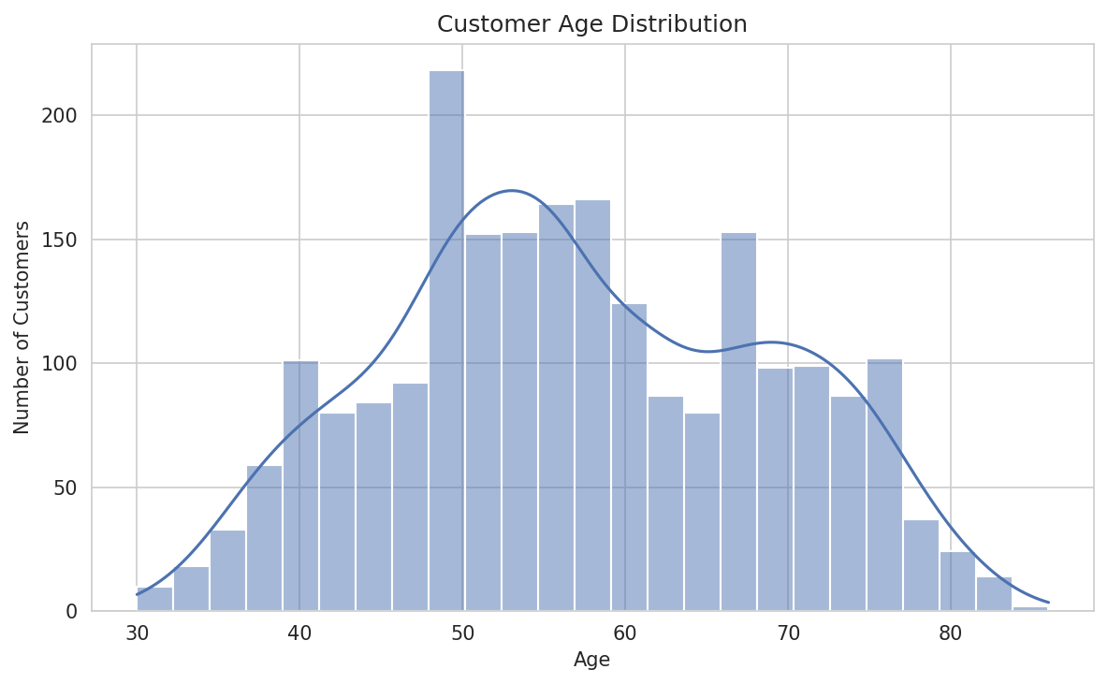
Figure 2.1 — Customer age distribution.
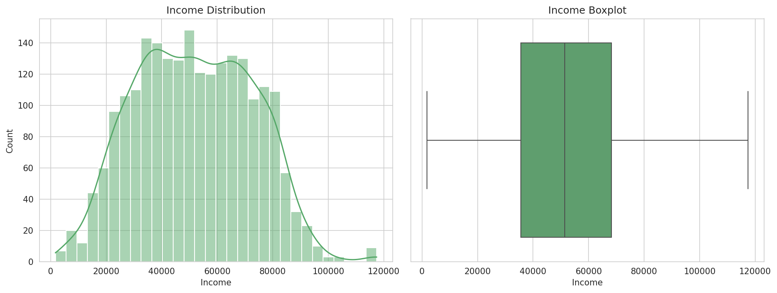
Figure 2.2 — Income distribution and boxplot.
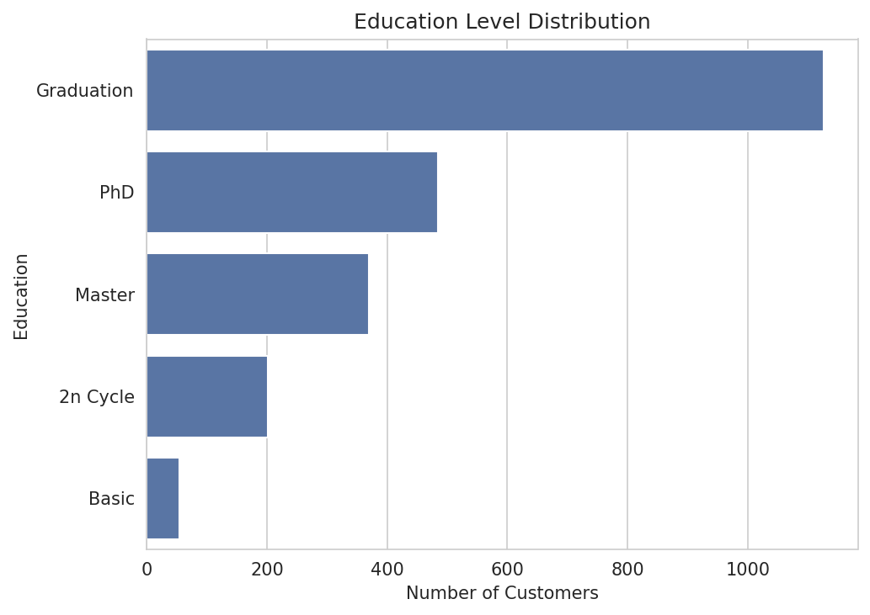
Figure 2.3 — Education level distribution.
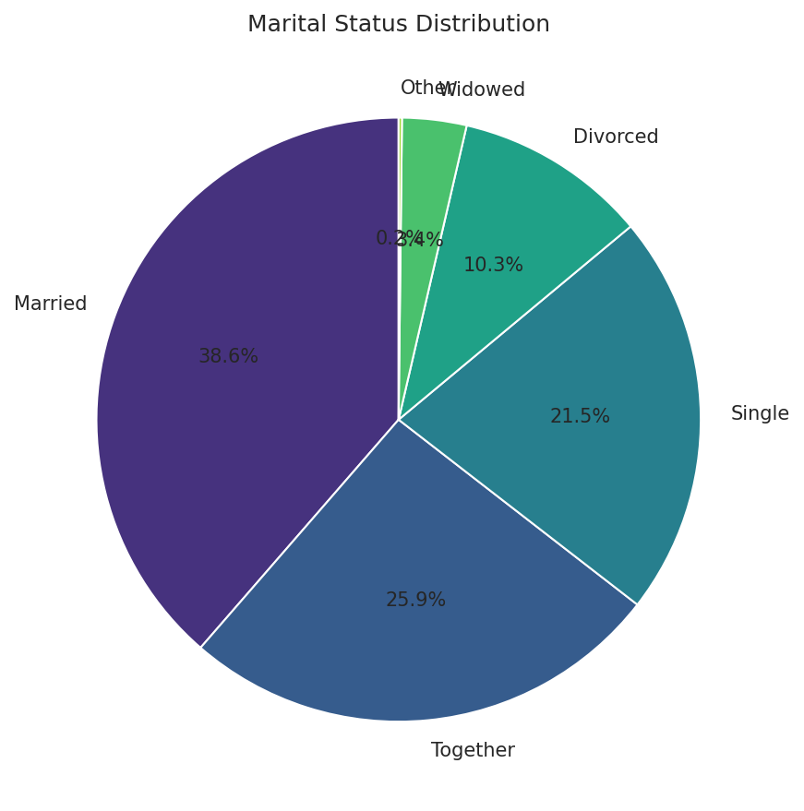
Figure 2.4 — Marital status distribution.
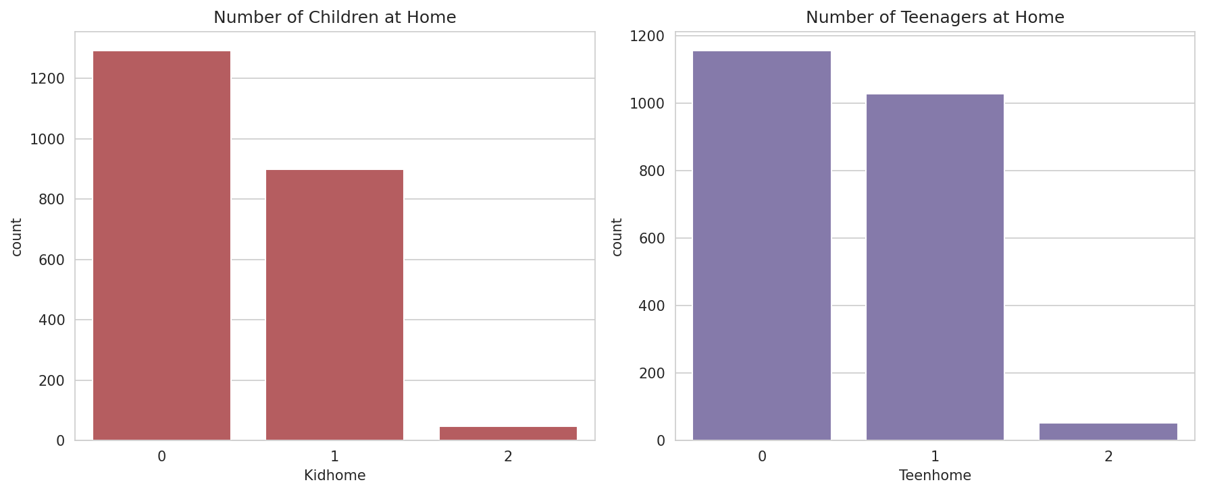
Figure 2.5 — Children and teenagers at home.

3. Customer Spending Analysis
Total spending across all customers is $1,355,048, averaging $605.74 per customer (median $396, reflecting a right-skewed distribution with a smaller group of very high spenders). Wine is by far the highest-revenue category, followed by meat products; fruits and sweets generate the least revenue.
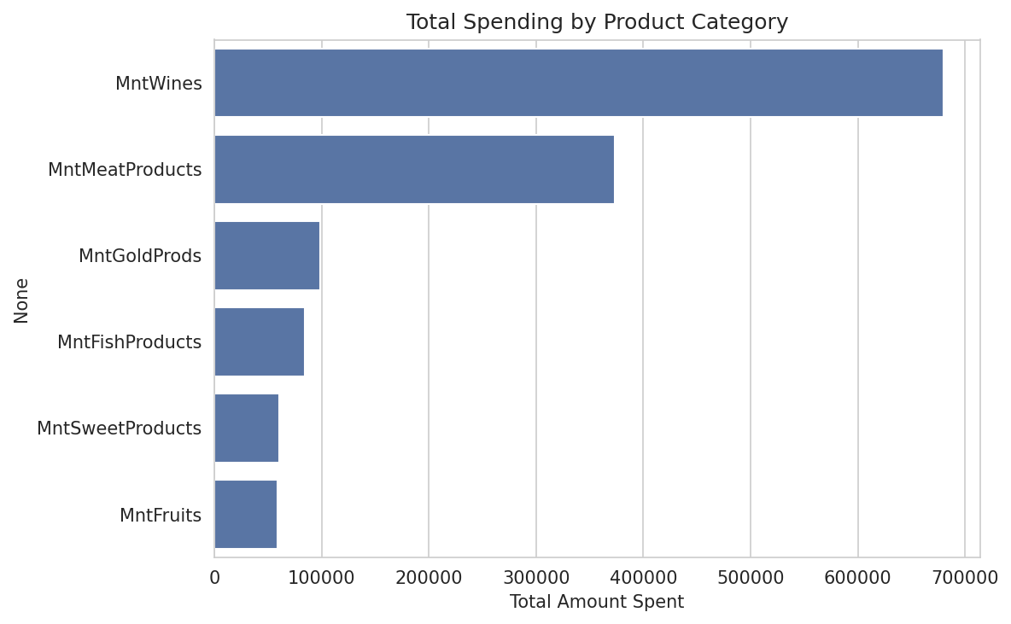
Figure 3.1 — Total spending by product category.
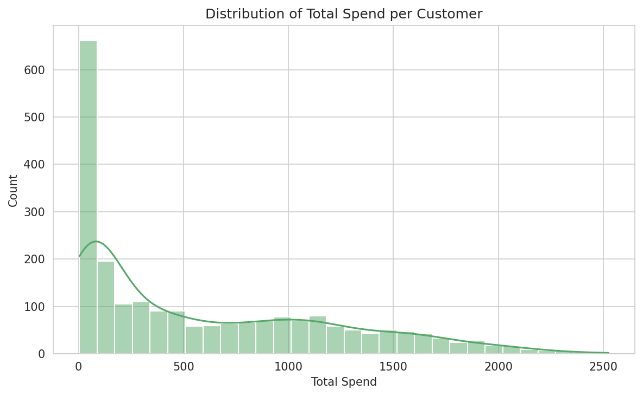
Figure 3.2 — Distribution of total spend per customer.
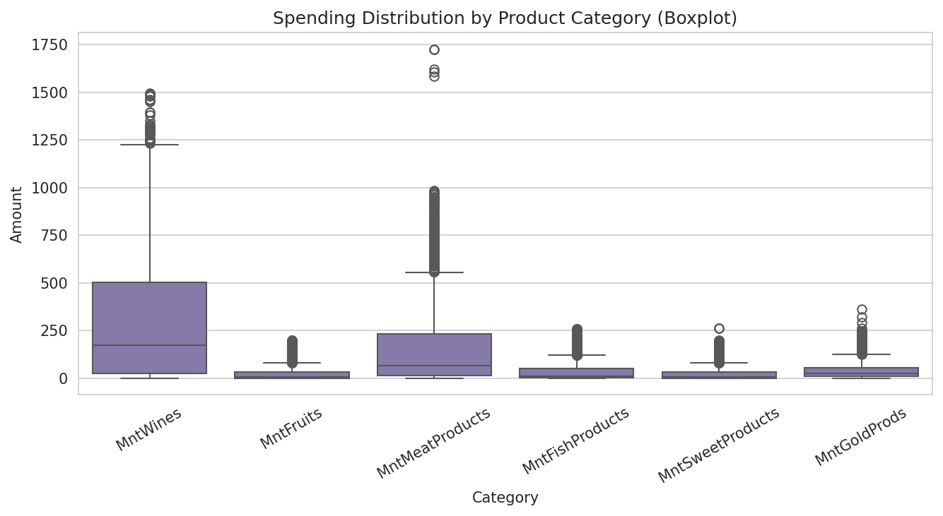
Figure 3.3 — Spending distribution by category (boxplot).
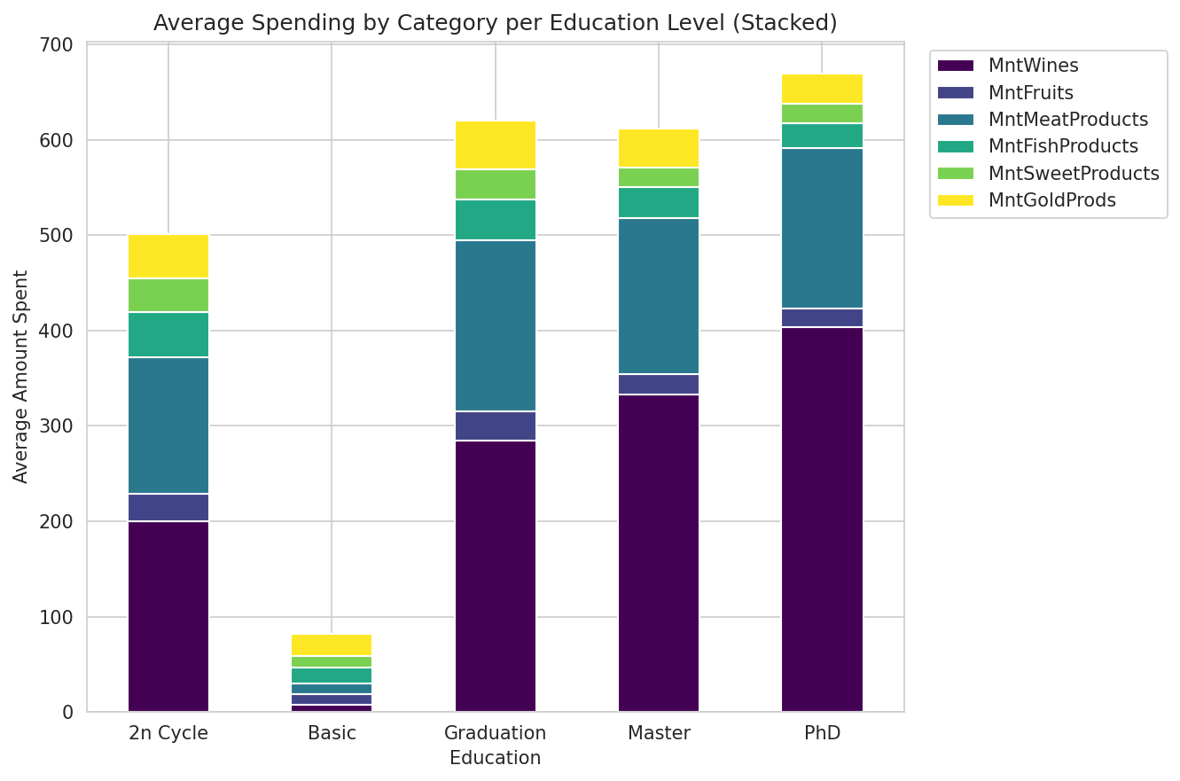
Figure 3.4 — Average spending by category per education level.

4. Purchasing Behavior Analysis
Store purchases are the leading channel (12,962 total, 5.79 per customer on average), followed by web purchases (9,143 total) and catalogue purchases (5,956 total). Deal/discount-driven purchases are the least common channel but still meaningfully used by a third of customers.
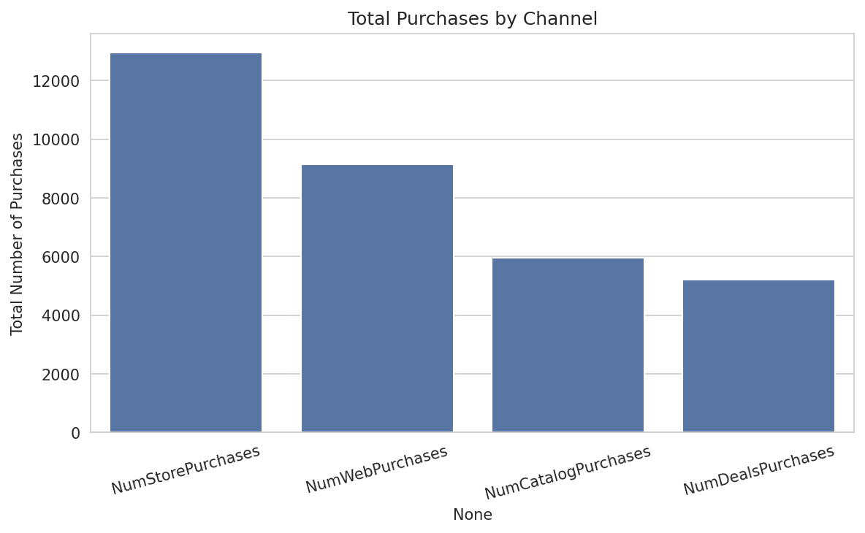
Figure 4.1 — Total purchases by channel.
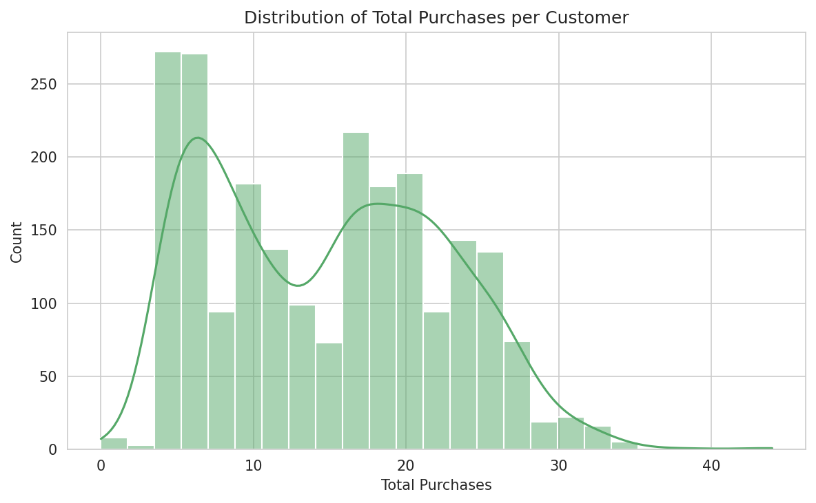
Figure 4.2 — Distribution of total purchases per customer.
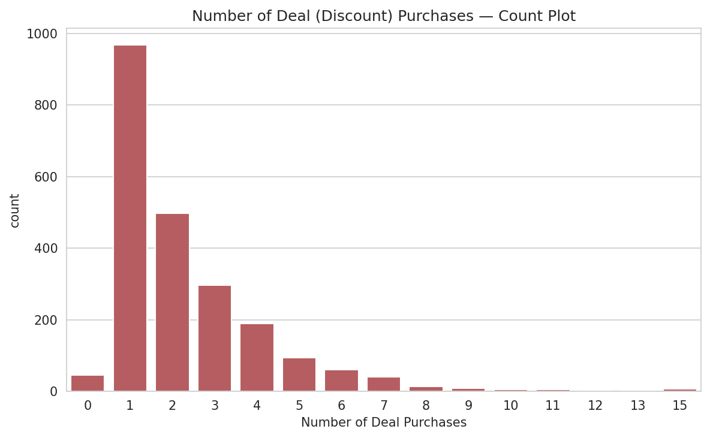
Figure 4.3 — Number of deal purchases per customer.

5. Website Engagement Analysis
Customers visit the website 5.3 times per month on average. Interestingly, website visits and web purchases show a weak negative correlation (-0.06), and income is strongly negatively correlated with web visits (-0.65) — suggesting lower-income customers browse more but convert less, while higher-income customers purchase through other channels.
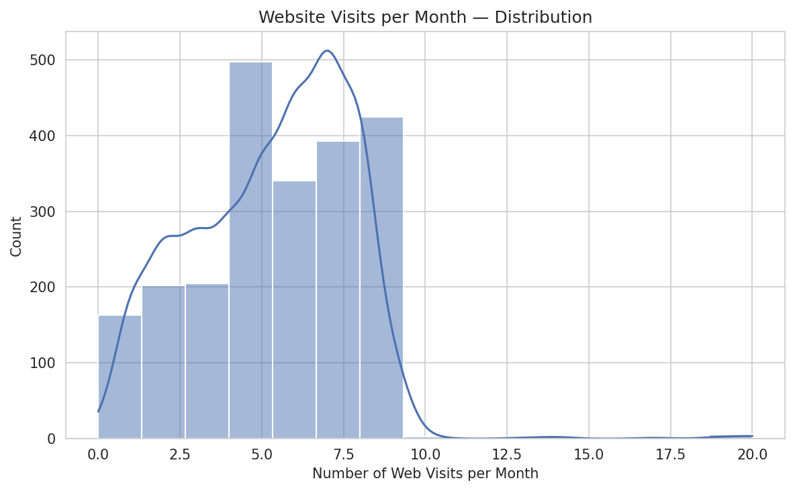
Figure 5.1 — Website visits per month.
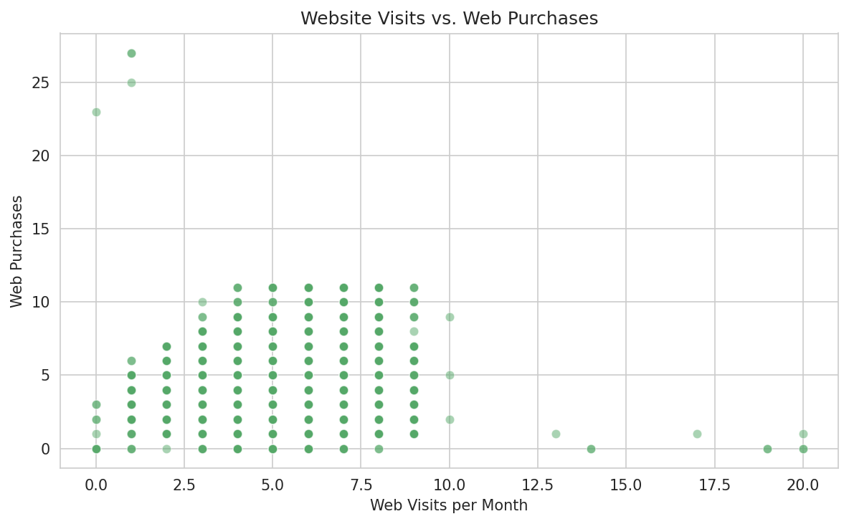
Figure 5.2 — Website visits vs. web purchases.
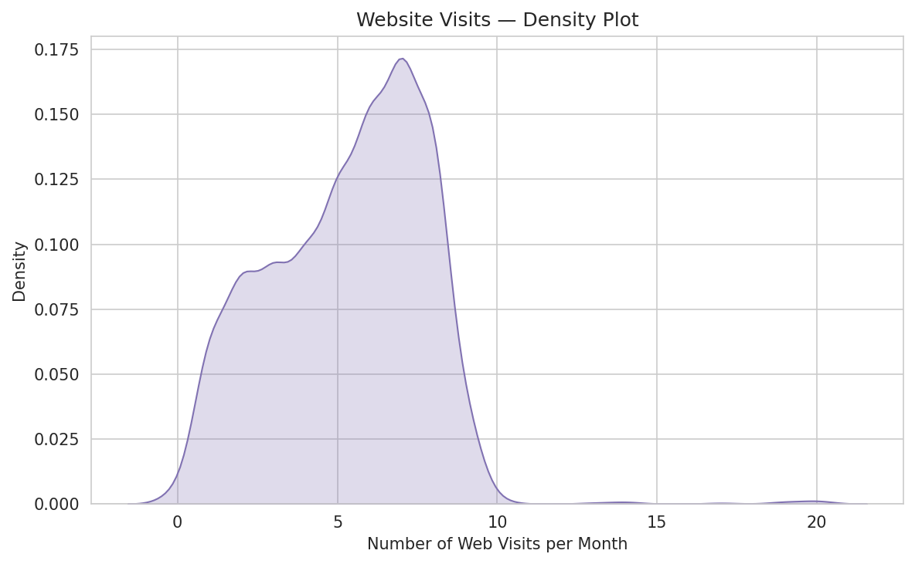
Figure 5.3 — Density plot of website visits.

6. Customer Recency Analysis
Recency (days since last purchase) averages 49.1 days, split almost evenly between active and inactive halves at the median. 533 customers have a Recency greater than 75 days and represent the priority group for re-engagement campaigns.
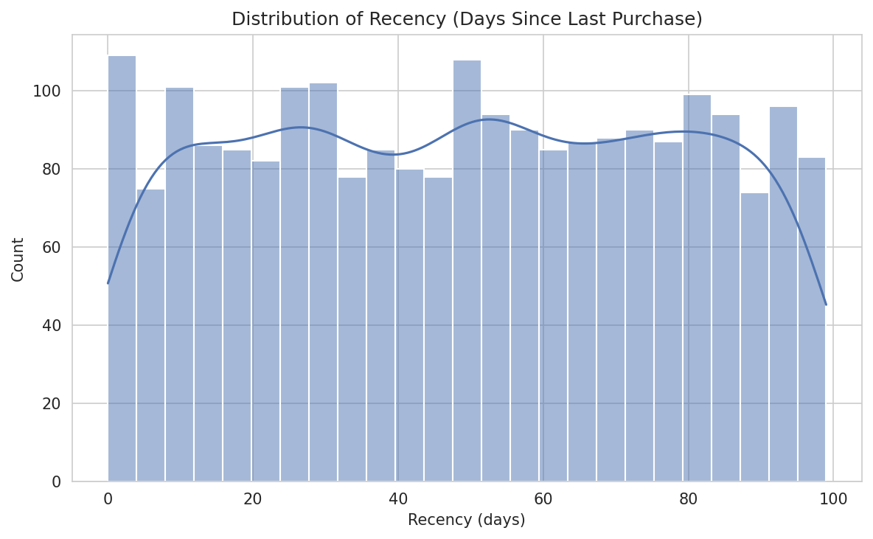
Figure 6.1 — Distribution of Recency.
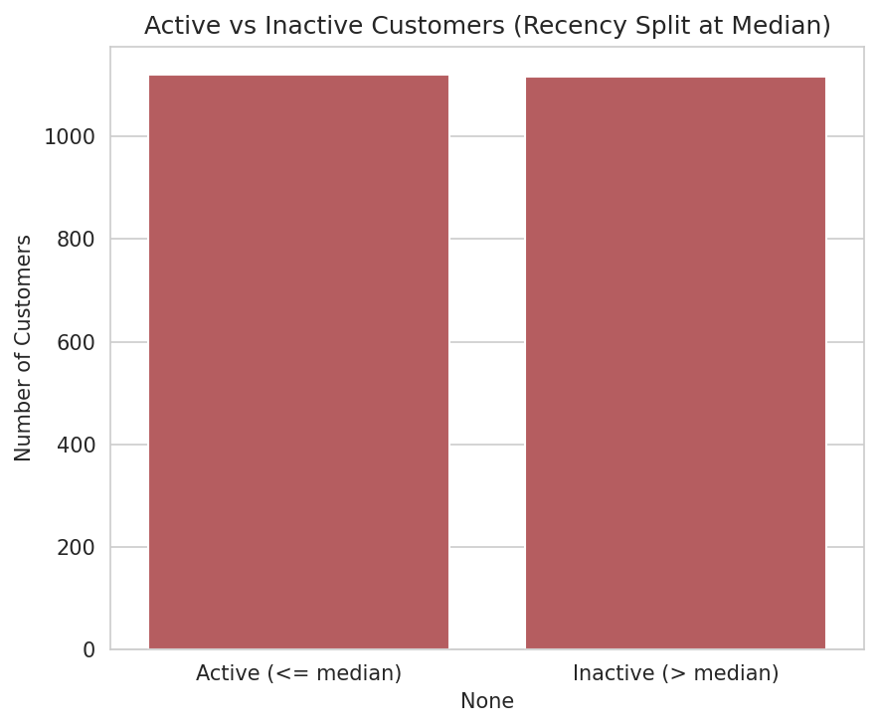
Figure 6.2 — Active vs. inactive customers (median split).

7. Marketing Campaign Analysis
The latest campaign (Response) achieved the highest acceptance rate at 14.93%, more than double any of the five prior campaigns. Campaign 2 performed worst (1.34%). Most customers accepted zero campaigns; a smaller group of repeat responders accepted two or more.
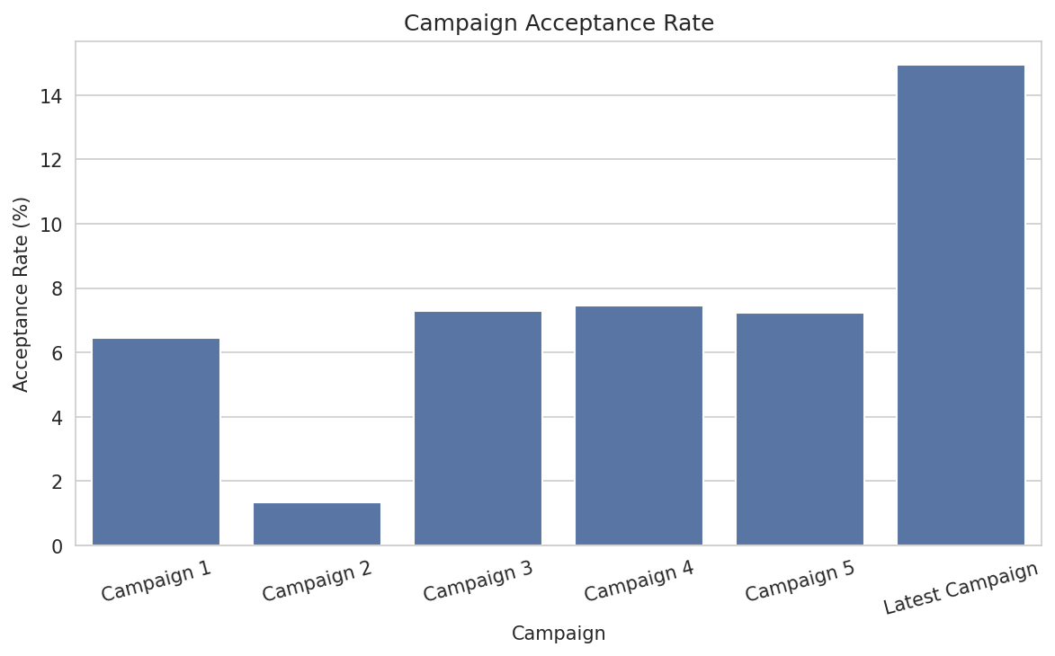
Figure 7.1 — Campaign acceptance rate.
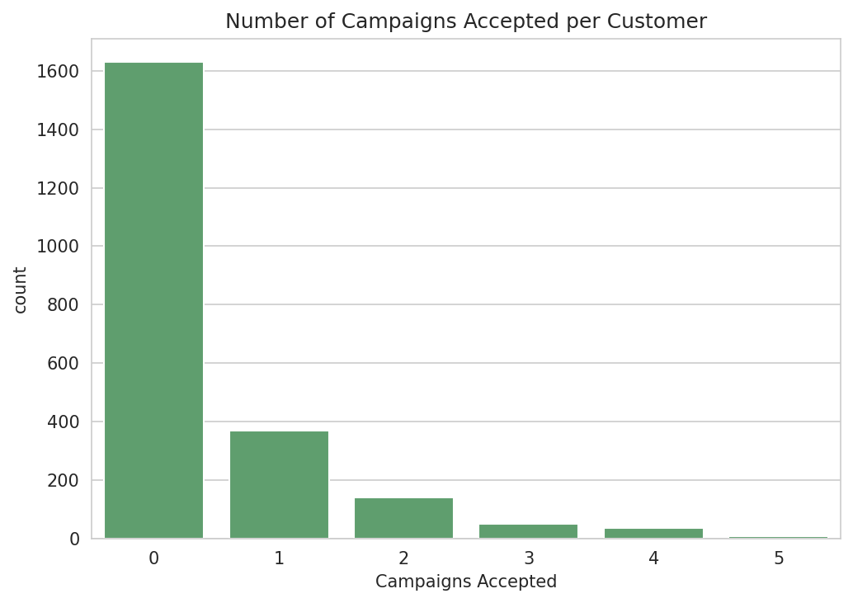
Figure 7.2 — Number of campaigns accepted per customer.
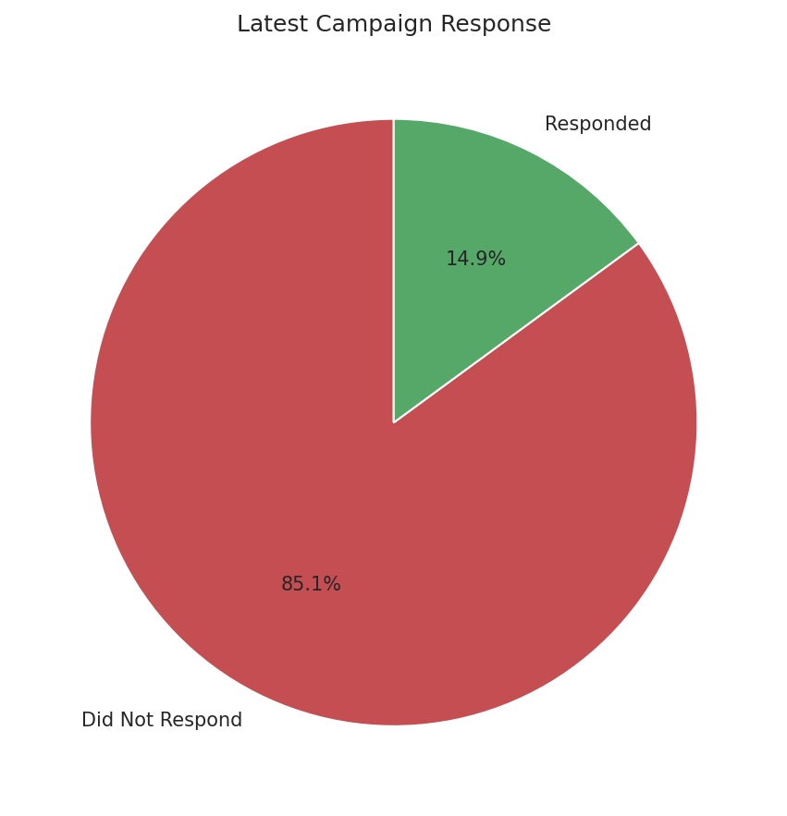
Figure 7.3 — Latest campaign response split.

8. Customer Complaint Analysis
Complaints are rare: only 20 customers (0.89%) filed a complaint. Complainers have both lower average income ($45,672 vs $51,911) and notably lower average spending ($392 vs $608) than non-complainers.
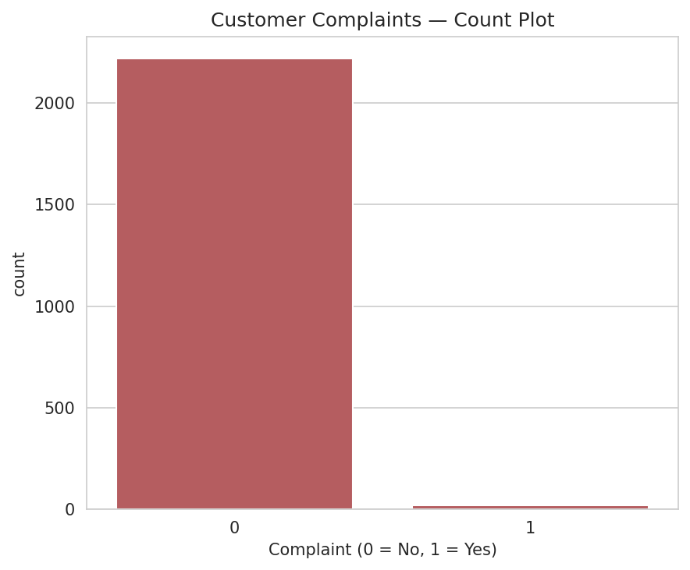
Figure 8.1 — Customer complaints count.
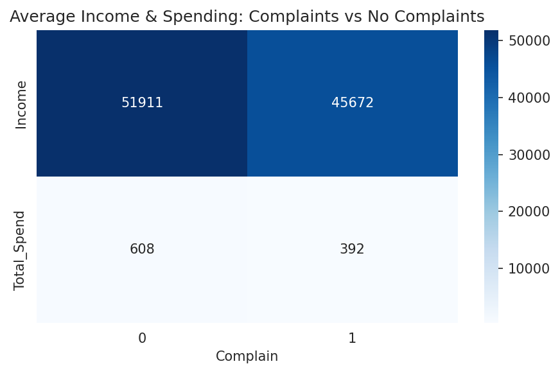
Figure 8.2 — Average income & spending: complaints vs. no complaints.

9. Correlation Analysis
A Pearson correlation matrix was computed across income, age, recency, total spend/purchases, web visits, and individual product categories. Spending categories are strongly positively correlated with each other and with Income (up to r ≈ 0.89 for Wine vs. Total Spend), while Income and Total Spend are negatively correlated with website visit frequency, and Recency shows little correlation with most other variables.
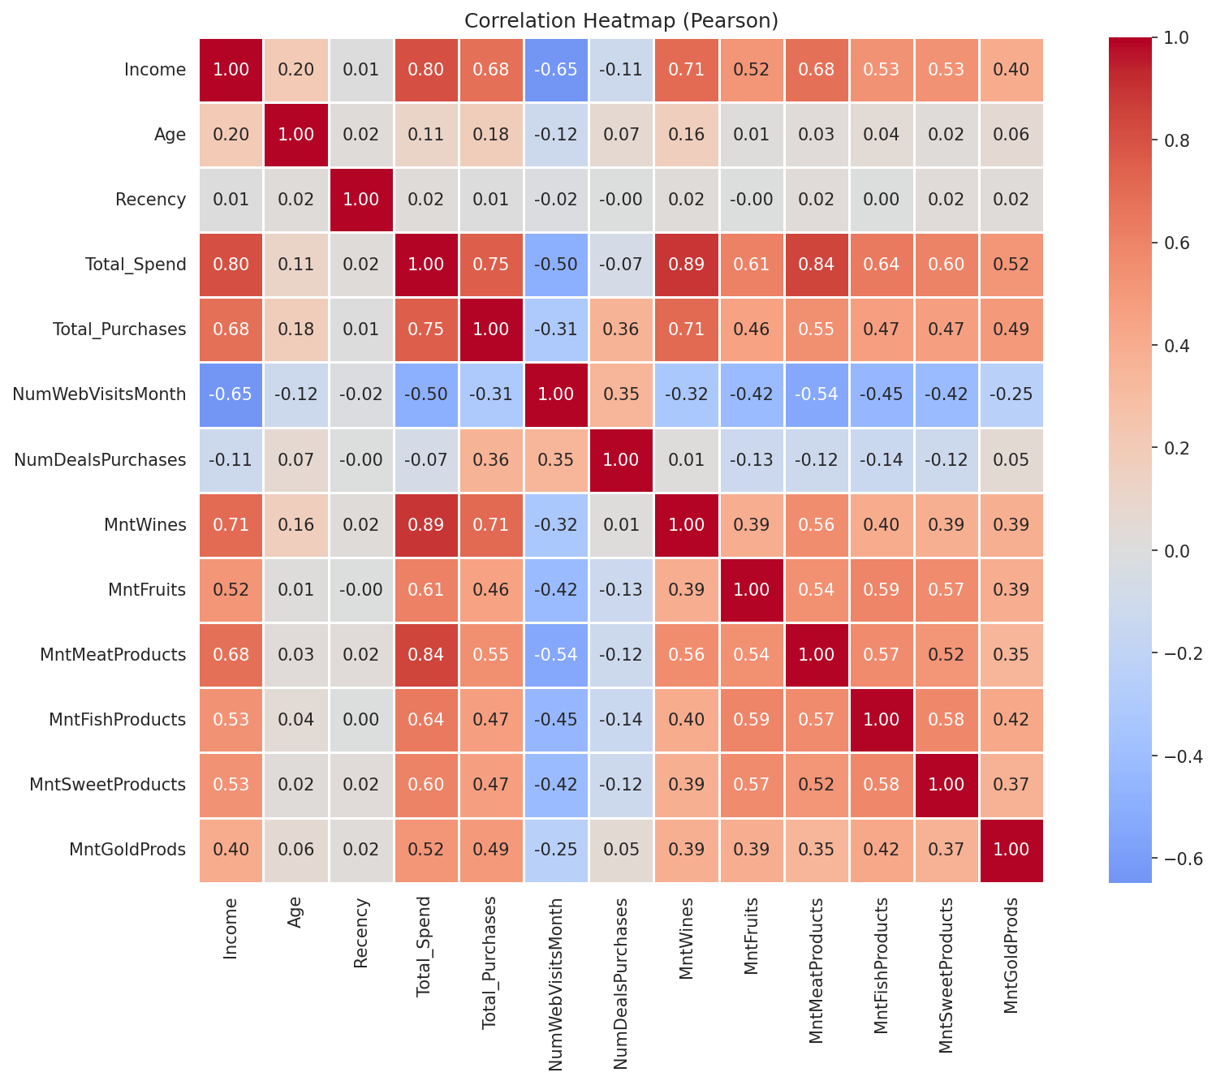
Figure 9.1 — Correlation heatmap (Pearson) across key numeric variables.

10. Customer Segmentation
Customers were segmented using quartile thresholds on spend, purchase frequency, deal usage, campaign response, and recency:
Segment | Count | % of Total
High-Value (Top 25% Spend) | 560 | 25.0%
Low-Value (Bottom 25% Spend) | 567 | 25.3%
Frequent Buyers (Top 25% Purchases) | 607 | 27.1%
Discount Seekers (Top 25% Deal Purchases) | 727 | 32.5%
Campaign Responders (>=1 accepted) | 608 | 27.2%
Loyal / Recently Active | 566 | 25.3%
Inactive (High Recency) | 576 | 25.7%
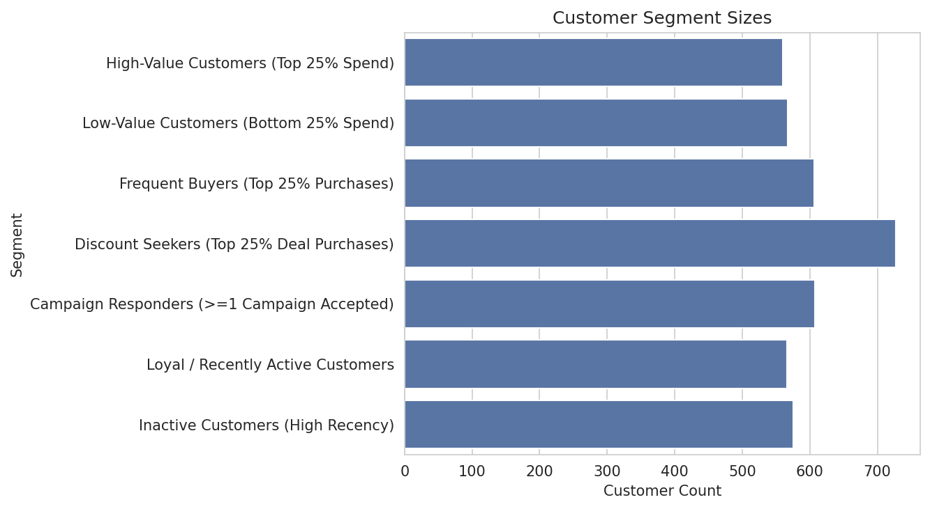
Figure 10.1 — Customer segment sizes.

11. Business Insights

Which customers spend the most?
High-income, older customers with fewer children at home; the top 10 spenders average $86,975 income vs. the overall average of $51,855.

Which product category generates the highest revenue?
Wine (MntWines) generates the highest total revenue among all six categories.

Does income influence spending?
Yes — Income and Total Spend correlate strongly (Pearson r ≈ 0.80).

Which purchase channel is most popular?
Store purchases, ahead of web and catalogue purchases.

Which campaign performs best?
The Latest Campaign (Response), with a 14.9% acceptance rate.

Which customers respond most frequently?
239 customers (10.7%) accepted 2+ campaigns — the most reliably responsive segment.

Which customers are inactive?
576 customers (25.7%) fall in the top Recency quartile and are candidates for re-engagement.

Which customers visit the website most?
The top 10 web visitors average 16.6 visits/month, though visit frequency does not translate proportionally into purchases.

Do customers with children spend differently?
Yes — households with children/teens spend $407 on average vs. $1,105 for households without.

What characteristics define high-value customers?
Higher income (avg $74,816), lower Recency, more store/catalogue purchases, and fewer children at home.

Which variables have the strongest correlations?
Wine spending and Total Spend show the strongest relationship; spending categories generally correlate strongly with each other and with Income.

What marketing strategies should be recommended?
Target high-income/low-recency customers with premium offers; launch win-back campaigns for the inactive segment; promote store/catalogue channels to frequent buyers; and offer value-oriented bundles to households with children.

12. Summary & Recommendations
- Prioritize win-back campaigns for the ~26% of customers with high Recency (inactive).
- Design premium bundles around Wine and Meat products for high-income, high-spend segments.
- Investigate why high web-visit customers convert less — possible UX or pricing friction on the website channel.
- Offer value/discount-oriented promotions to households with children, who spend less on average.
- Use the top-performing 'Latest Campaign' format as a template for future campaign design.
- Proceed to customer segmentation modelling (e.g. clustering) using Income, Total_Spend, Recency and Total_Purchases as core features.

